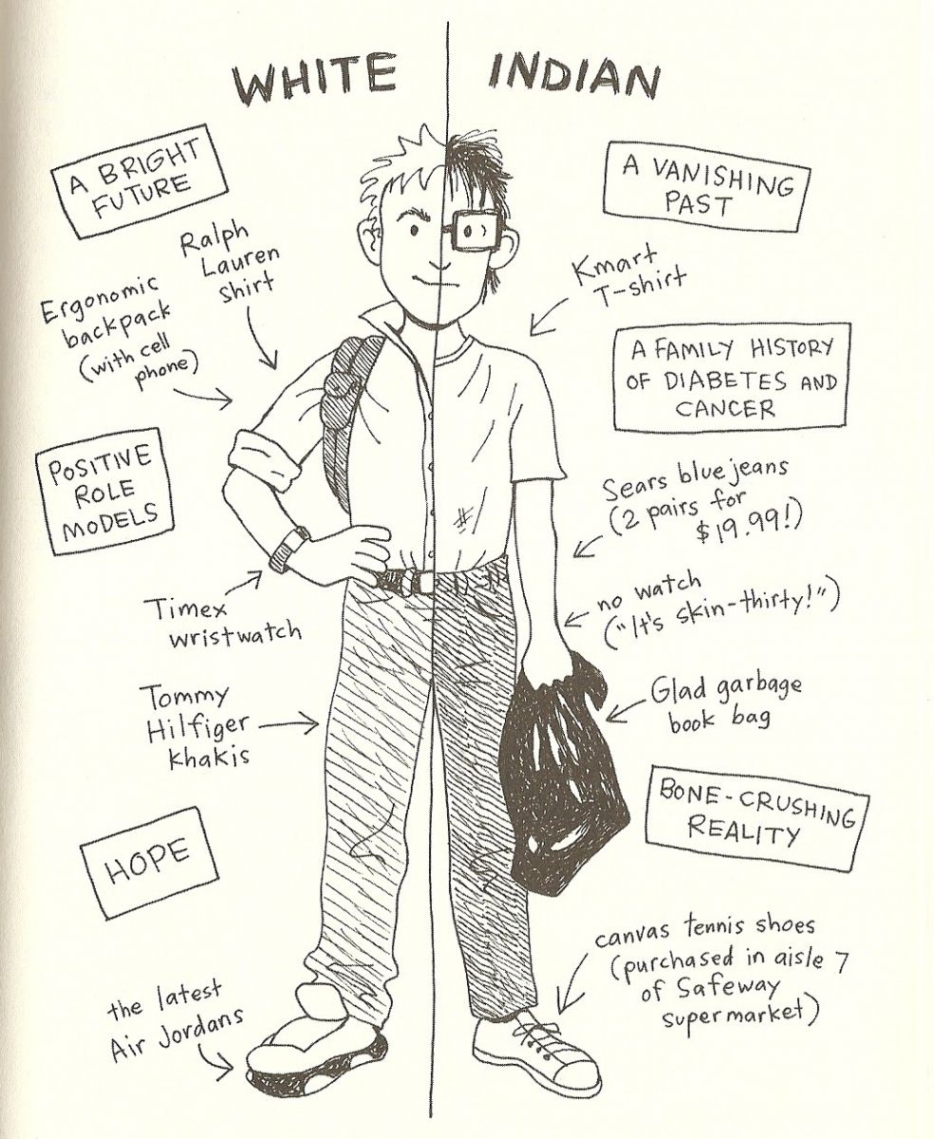While reading *The Absolutely True Diary of a Part- Time Indian,* write down as much information about Junior, the protagonist and narrator, as you can find. Don't forget to write down the number of the page and the line(s) where you have found some information!

**What does he look like?**

* He has a enormous skull S12 Z30
* big feet and a pencil body S12 Z28
* He has 42 teeth S12 Z1
* Ugly thick black plastic glasses S12 Z16
* Skinny S12 Z26
* Looks goofy S13 Z5

**Family (members, background, living conditions etc.), friends**:

S23 Mom reads a lot of books, can recite whole pages

S23 Dad can sing good play the guitar, piano and saxophone

S25-10 Rowdy is his best friend

S25-7 He the toughest kid on the rez

S28-1 He fought everybody

S37 His Sister is called Mary Runs away

S48-9 She want to writte romance novels

S37 She lifed in the basement

S37 She locks good

S36-23 She’s funny

Grandmother she’s smart and give a lot of advice

Eugen is the best the best friend of Alexis father and have an old timer bike

Penelope is a classmate from Alexi, she’s beautiful and collect spare change for homeless people

Roger is alpha guy of the school, and Alexie punched him in the face

Gordy is a smart guy

S102,25 he’s big, he’s a geek

S102 he’s a friend of Arnold

S105 like books very much

Penelope

She’s beautiful

S115,7 bulimic

S116,10 is lonely, her life isn’t perfect, pretty smart popular

Friend of his Sister

Is a gambler

Lives in Montana

Earl Penelope’s Father

S117 He’s a racist

**Hobbies and interests**:

Drawing cartoons and reading books S14 Z14

Mastrubating

Hangin‘ out with Rowdy

Want to go to Reardan School S60

**Character traits (from what he says himself and from what you learn from his behavior):**